ATF

Difference between Standard UI (Developer View) and Agent Workspace (Client View)

TESTCASE1: Creating a Test Case to Open the incident form and set field values in Standard UI

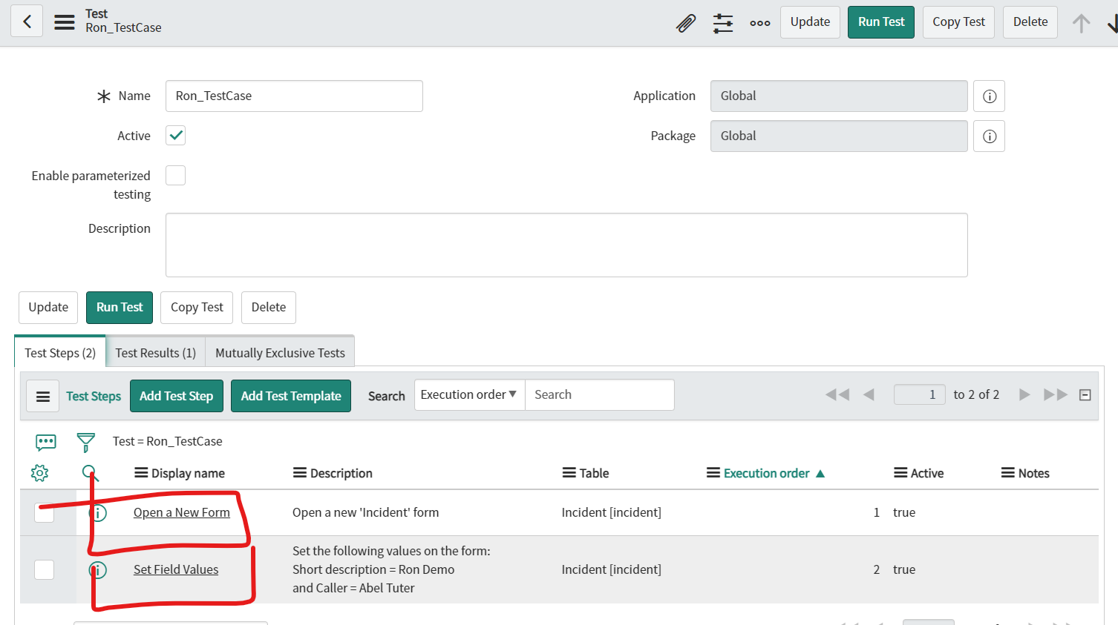

TestSteps:

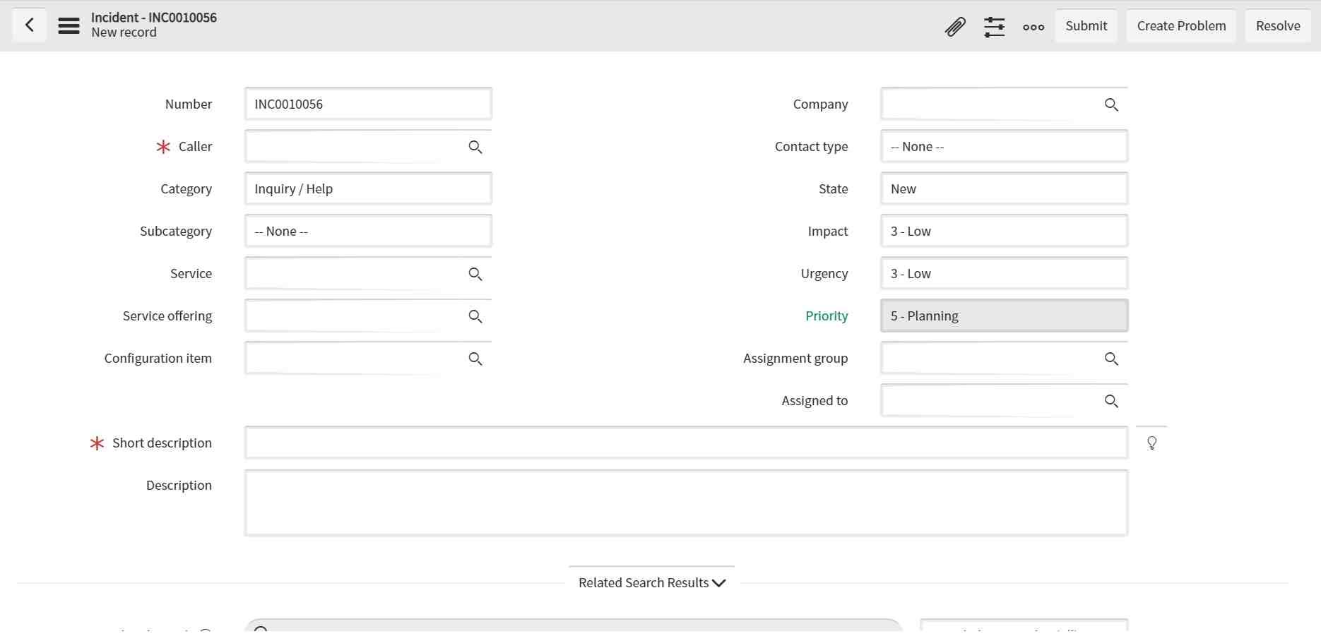

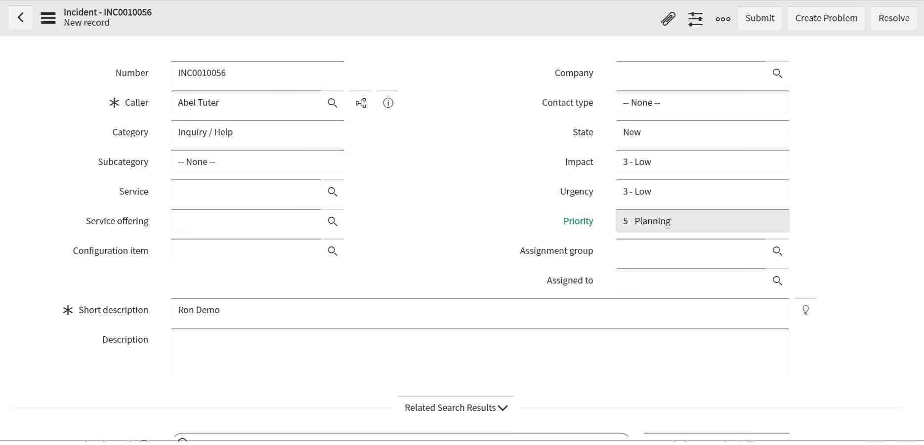

TestResult:

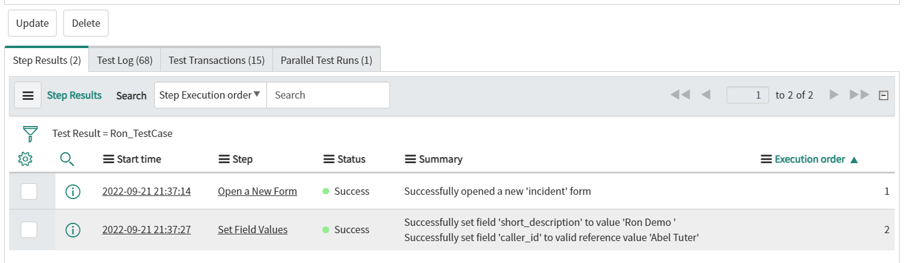

TESTCASE2: Creating a Test Case to Open the incident form in Agent View and set field values in Standard UI

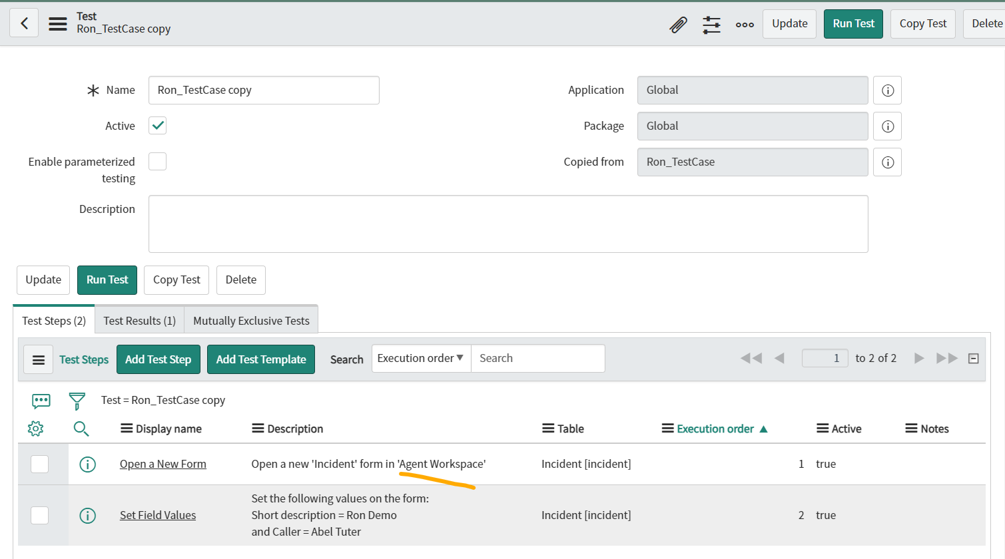

TestStep:

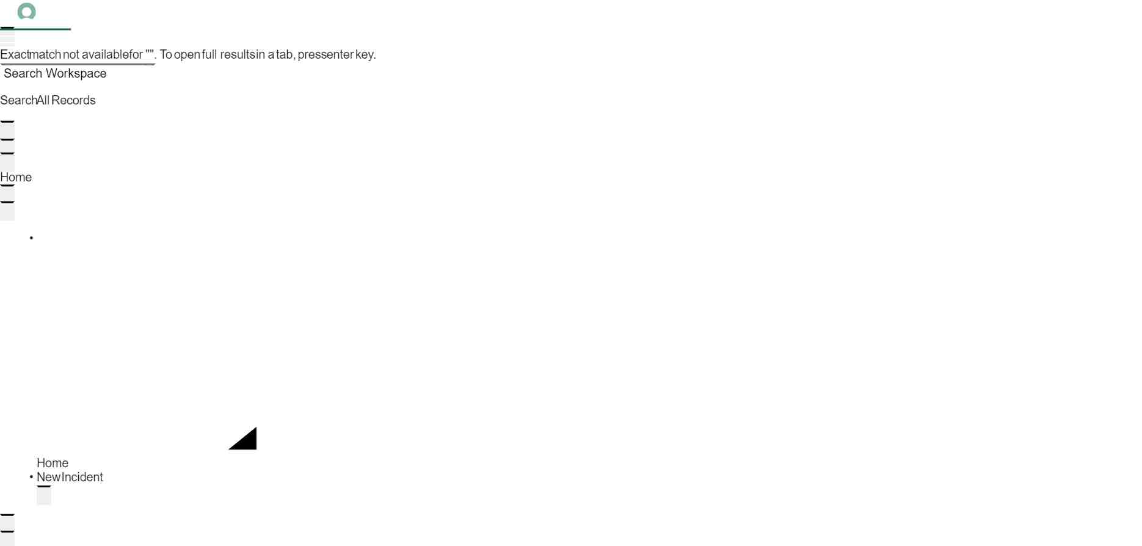

TestResult:

